Quantum Mechanics

1. Electrons are incredibly small.

A single speck of dust has more electrons than the number of people who have ever lived on Earth.

Electron behavior determines much of the behavior of atoms.

Directly observing electrons in the atom is impossible; the electron is so small that observing it changes its behavior.

Even shining a light on the electron would affect it.

2. Quantum mechanics forms the foundation of chemistry.

Explaining the periodic table

The behavior of the elements in chemical bonding

Provides the practical basis for lasers, computers, and countless other applications

3. The quantum-mechanical model explains the manner in which electrons exist and behave   
in atoms. The electron behaves as a wave and as matter. Light also behaves as a wave and matter. Light is electromagnetic radiation. To understand electrons, we study light.

4. **Electromagnetic Radiation** is a form of energy having both wave and particle characteristics.

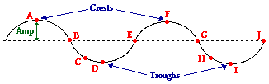

5. **Wavelength (λ)--**length between 2 successive peaks of the wave.

6. **Frequency (**υ**)--(nu, not v),** the number of wavelengths that pass a given point in a second.

7. **Velocity (c)-** all electromagnetic radiation moves through a vacuum at the same velocity, the speed of light, 3.0 X 108m/s.

**velocity = λ υ**

Notice that wavelength and frequency are inversely proportional.

8. **Electromagnetic spectrum**- all the wavelengths of radiant energy from short gamma to long radio waves.

The higher the frequency, the higher the energy.

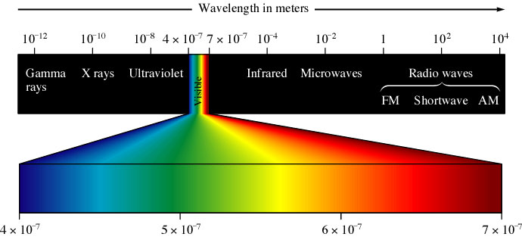

**Frequency of Electromagnetic Radiation**

9. Quantum or photon- a specific particle of light energy that can be emitted or absorbed as electromagnetic radiation.

10. Planck demonstrated that energy is gained or lost by atoms in quantized units.

**ΔEnergy = nhυ**

h = 6.6260755 x 10-34 joule • seconds. n- interger or multiple

υ = lowest frequency that can be absorbed or emitted by the atom

All energy gained or lost by atoms is a whole number multiple of hυ. Hence the step-wise or quantum nature of energy change.

**Continuous Spectrum**- when white light (ROY G. BIV) is passed through a prism it shows a rainbow pattern made up of its component wavelengths.

11. When the electrons in an atom are excited, the electrons are promoted to a higher energy level. They are unstable and eventually return to their ground state ( stable place). When they do, they emit a photon of light in a certain wavelength. The pattern of wavelengths is called **Line Spectra** and is unique to each element. The lines represent the energy levels that are

allowable for that element.



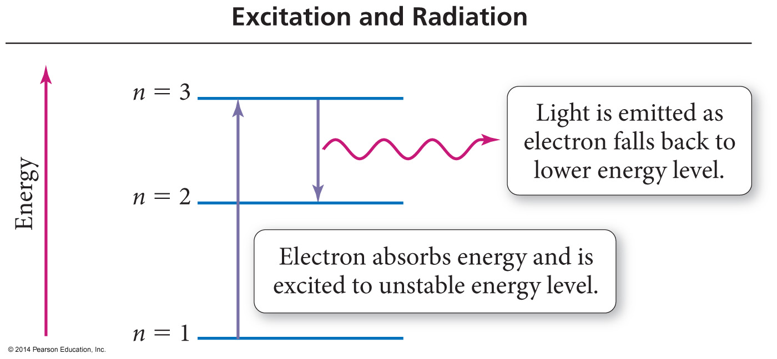

12. Equation for the energy change when an electron moves from one level (ninitial) to another level (nfinal).

**E = - 2.178 X 10-18J ( 1 - 1 )**

**(nfinal)2 (ninitial) 2**

n= energy level. This represents the energy emitted by the electron as it returns to a more stable, lower energy level.

**Exercise 4 Energy Quantization in Hydrogen**

Calculate the energy required to excite the hydrogen electron from level n = 1 to level n = 2. Also calculate the wavelength of light that must be absorbed by a hydrogen atom in its ground state to reach this excited state.

**∆E = 1.633 X 10-18 J**

**λ = 1.216 X 10-7 m**

N2 molecules absorb ultraviolet light but not visible light. I2 molecules absorb both visible and ultraviolet light. Which of the following statements explains the observations?

a. More energy is required to make N2 molecules vibrate than is required to make I2 molecules vibrate.

b. More energy is required to remove an electron from a I2 molecule than is required to remove an electron from a N2 molecule.

c. Visible light does not produce transitions between electronic energy levels in the N2 molecule but does produce transitions in the I2 molecule.

d. The molecular mass of I2 is greater than the molecular mass of N2.

**Exercise 2 The Energy of a Photon**

The blue color in fireworks is often achieved by heating copper(I) chloride (CuCl) to about 1200°C. Then the compound emits blue light having a wavelength of 450 nm. What is the increment of energy (the quantum) that is emitted at 4.50 X 102 nm by CuCl?

**= 4.41 X 10-19 J**